Internal Referrals

DEVELOPMENT ENGINEERING REFERRAL
Location: 360A Lanyon Drive, Tralee
Lot 6 DP 239080, Lot 1 DP 213249 and Lot 1 DP 313299

DA.2020.1351 – Construct Recreation Facilities (Indoor and Outdoor)

Date: 8/09/2020
Sewer Available: No Driveway Access: No
Water Available: No Kerb and Gutter: No
Flood Category: 1% AEP (FPL) Footway Width: N/A
Natural Water Course: Jerrabombera Creek Footway Grade: N/A

Drainage Easements: existing easement over property or adjoining land
easement required over property or adjoining land
Hydraulics: attached unavailable at time of assessment irrelevant
Subdivision Works Construction Certificate required: Yes No
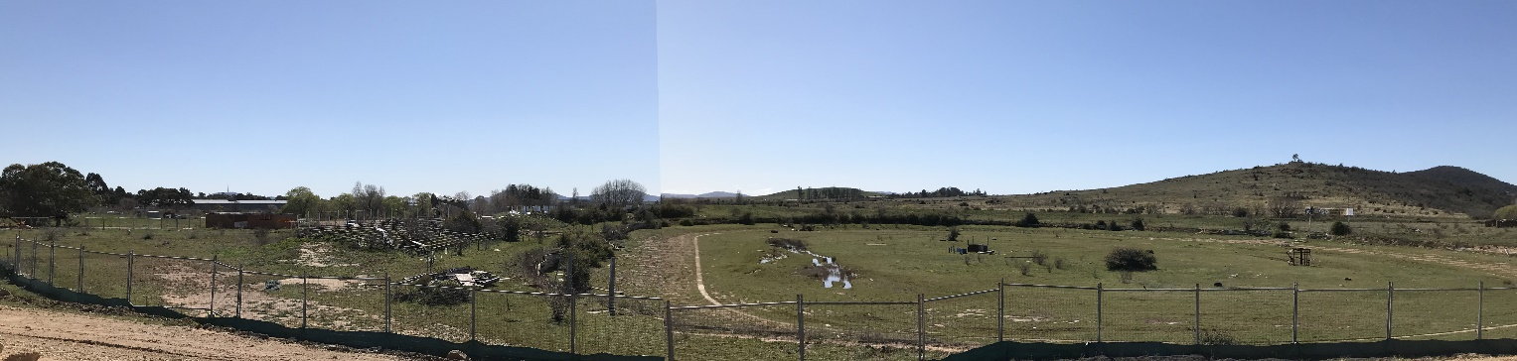

Proposal
Construction of a sports complex adjacent to the new release of Stage 1A of Tralee on Lot 6 DP 239080, Lot 1 DP 213249 and Lot 1 DP 313299. The proposed Queanbeyan-Palerang Regional Sports Complex (QPRSC) is to deliver a high quality and cohesive sporting precinct, including a basketball stadium, major sports pavilion, two minor sports pavilions, hockey and soccer sports fields, new shared pathways, vehicle connections and internal movement, car parking, built form and supporting amenities.
The proposed sports fields and courts proposed for the QPRSC precinct are;
- 4 Basketball courts,
- 2 Hockey fields,
- 4 Soccer fields, and
- 6 Rugby League/Union fields.
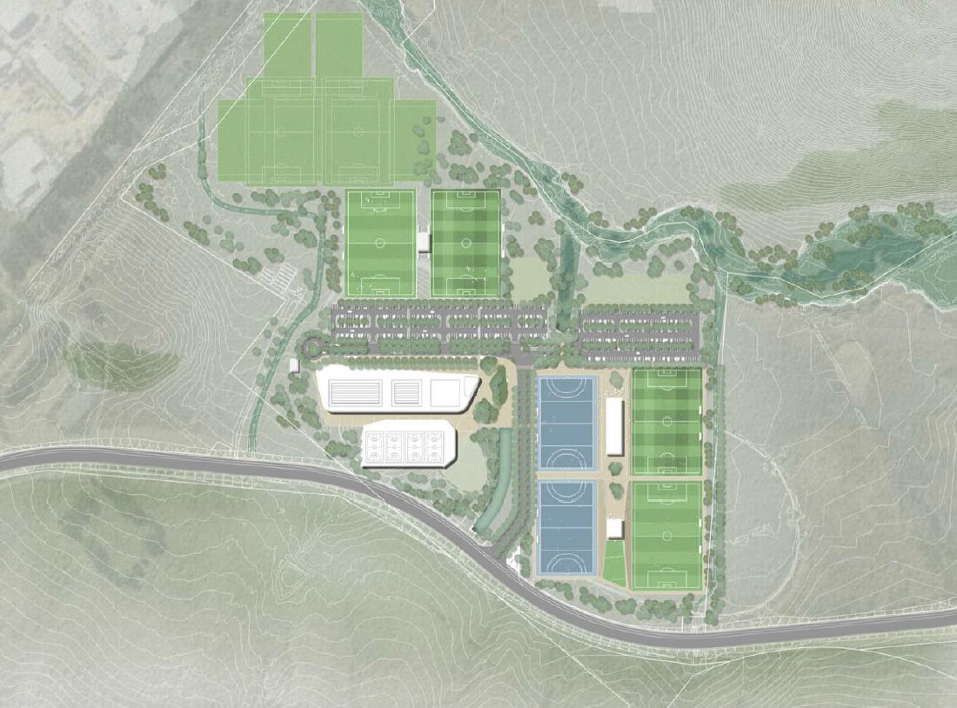
Regional Sports Complex Concept – 360A Lanyon Drive, Tralee

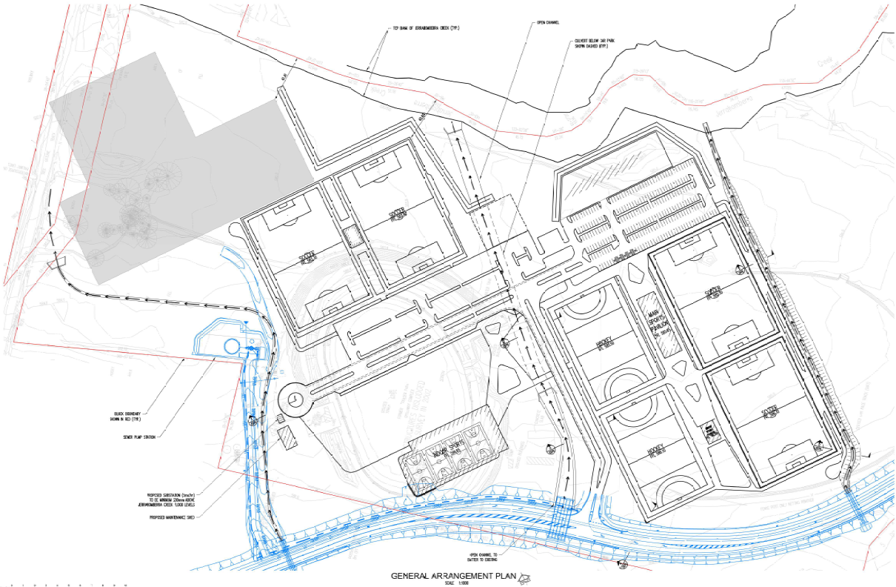
General Arrangement Plan – 360A Lanyon Drive, Tralee
Water
The development site is not currently serviced by any connection to the South Jerrabomberra water network.
A new local water supply 300mmØ DICL water main will be located adjacently to the south within the Northern Entry Road reserve corridor, which will run parallel with the 225mmØ potable water main to the reservoir. A future 300mmØ DICL connection is provided and reference as Line 06 terminating at a hydrant. In addition, there is a proposal for connection to a new recycled water main installed as separate infrastructure. The design of the new irrigation system will be coordinated with Council representatives overseeing the design of the new recycled water treatment plant and distribution system.
The size of the new 300mmØ DICL and hydrant water main, connecting water service required for the basketball stadium, major sports pavilion, two minor sports pavilions and recycled water system for playing field irrigation is to be calculated by a specialist hydraulic consultant specifying the required service size suitable for functionality.
The local 300mmØ DICL water main and connection locations can be identified on the SEC68.2020.1069 approval plan by Calibre Local Water Supply Plan 17-001472 Sheet 5 of 5 R584 Issue B.
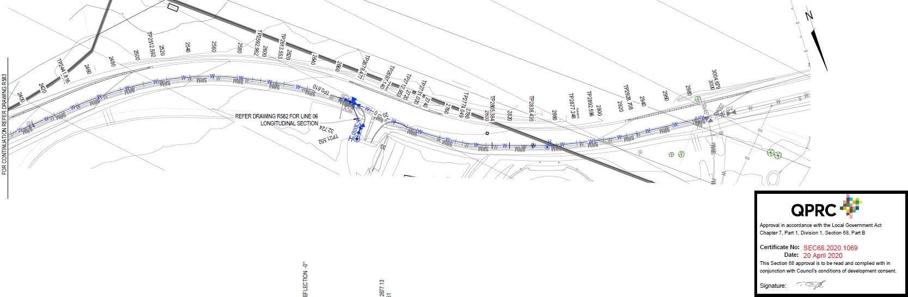
Proposed Water Utilities Plan – 360A Lanyon Drive, Tralee
Sewer
The development site is not currently serviced by any connection to the Queanbeyan West sewer network.
A new sewer pumping station located adjacently to the west is proposed to service the QPRSC, discharging to new 250mmØ sewer rising main and infrastructure within the Northern Entry Road reserve corridor.
The sewer pump station and rising main locations can be identified on the SEC68.2020.1069 approval plan by Calibre Sewer Plan And Profile 180Ø Temp & 250Ø Ultimate Rising Main 17-001472 Sheet 1 of 4 R513 Issue H.
In accordance with Water Services Association Australia Sewerage Pumping Station Code WSA 04-2005 any new rising mains up to and including 100mmØ shall be uPVC material pipe.
The QPRSC site will be serviced a new gravity sewer main and connection to the new pumping station.
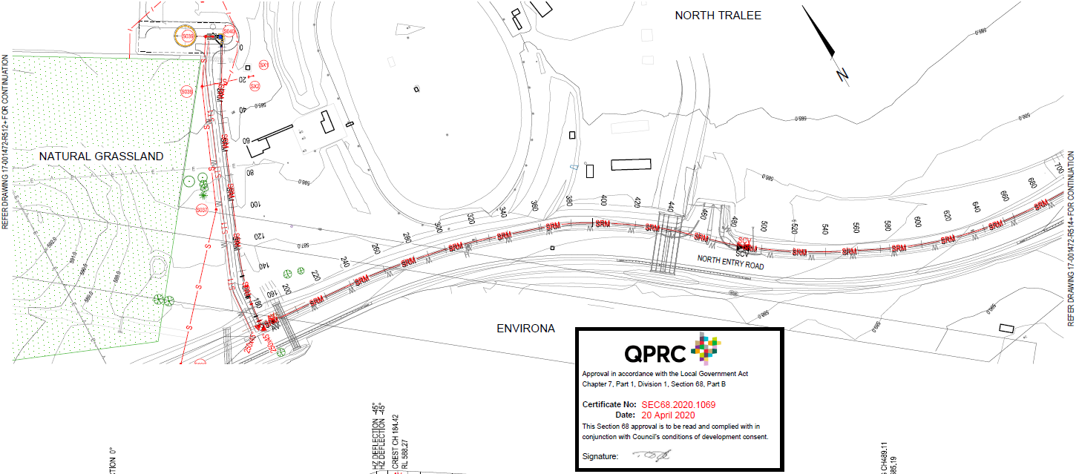
Proposed Sewer Utilities Plan – 360A Lanyon Drive, Tralee
Storm Water
The proposed development of the site is likely to increase runoff, thus a stormwater management plan demonstrating the proposed development can maintain pre-development runoff flow for both 20% and 1% storm events is required in accordance with Council’s D5 Stormwater Drainage Design specification, and provision for onsite stormwater detention (OSD) and water quality in accordance with Council’s D7 Erosion Control and Stormwater Management Design specification and corresponding computer modelling.
Referring to Section 4.4 of the Statement of Environment Effects as prepared by Cardno Pty Ltd dated 24 July 2020, the following methodologies have been implemented to capture and filter stormwater runoff prior to being mechanically filtered and treated before being stored onsite for re-use;
- Car park pavements are generally drained to landscape buffer zones for filtering before being piped to retention tanks,
- Road pavements are picked up at the kerbs with minimal filtration offered,
- Roof runoff shall be collected and piped to the retention tanks. Consideration shall be given to providing separate piped systems to convey the clean roof water to the retention tanks as they will require significantly less filtering and treatment,
- Stormwater runoff from the fields shall be collected in the subsoil system and perimeter drains before being collected in the retention tanks.
Three trunk drainage channels are located within the QPRSC site to convey stormwater runoff from the South Tralee Development through the site to Jerrabomberra Creek.

Erosion and Sediment Control
An Erosion and Sediment Control Plan (ESCP) will be required for any works causing surface cover disturbance. An ESCP will be required to be submitted with the construction certificate. A Soil and Water Management Plan (SWMP) will be required to be implemented by the property owner for any works causing surface cover disturbance. This requirement applies for all stages of development.
Referring to Section 4.5 of the Statement of Environment Effects as prepared by Cardno Pty Ltd dated 24 July 2020, recommends stormwater diversion channels be formed in the early stage of the construction phase due to the large extent of the earthworks.

Traffic and Parking
The site shall meet the requirements of AS/NZS 2890.1-2004 Parking Facilities Off-Street Car Parking, AS/NZS 2890.6-2009 Off-Street Parking for People with Disabilities, and Queanbeyan DCP 2012 Clause 2.2. All parking spaces must meet the functionality of the Australian Standard as a minimum.
Referring to Section 4.2 of the Statement of Environment Effects as prepared by Cardno Pty Ltd dated 24 July 2020 and Traffic and Parking Assessment as prepared by TTW in May 2020 the parking requirements for the QPRSC have been assessed based provisions of similar facilities within the QPRC Local Government Area area and the ACT. The Traffic and Parking Assessment Based states that upon completion of the QPRSC development, 328 car spaces would be required based on the following parking provisions;
- Basketball - 7 car spaces per court (4 courts = 28 car spaces),
- Hockey - 20 car spaces per field (2 fields = 40 car spaces),
- Soccer - 20 car spaces per field, (4 fields = 80 car spaces) and
- Rugby League/Union – 30 car spaces per field (6 fields = 180 car spaces).
Subsequently, the proposed QPRSC development provides a total of 300 car parking spaces for Phase 1 of the DA which does not include the Basketball courts. However, the ultimate development which includes an Aquatic Centre (not part of this DA) provides 448 car parking spaces, 19 DDA complaint car parking spaces and 7 buses, making provision for a further 100 car parking spaces or 9 buses to the north of soccer fields.
There are five (5) disabled car parking spaces provided throughout QPRSC car parks located adjacent to the main sports pavilion.

Entrance and Access
In accordance with the Queanbeyan DCP 2012 Clause 2.2 Parking, specifically the access to the various QPRSC car parks must demonstrate two way or separate access and egress allowing all vehicles to enter and leave in a forward direction.
The internal roads and access from the Northern Entry Road appears to have been designed based on passenger vehicle manoeuvrability and car park functionality for B99 vehicle and coaches with separate access and egress allowing all vehicles to enter and leave the QPRSC in a forward direction.
Referring to Section 4.2 of the Statement of Environment Effects as prepared by Cardno Pty Ltd dated 24 July 2020 and Traffic and Parking Assessment as prepared by TTW in May 2020 indicates a maximum average peak weekend volume of 240 vehicles per hour (478.68 AADT) where all junior and senior sports are played, and the Northern Entry Road intersection geometry as developed with QPRC, Calibre/Spiire, VBC and TTW is deemed compliant for this development.

Flooding
The QPRSC development is within the 1% AEP Flood Area. The submitted Statement of Environment Effects as prepared by Cardno Pty Ltd dated 24 May 2020 and Flood Impact Assessment as prepared by Lyall & Associates (L&A) dated March 2020 states the greater site is located adjacent to Jerrabomberra Creek and is subject to flooding.
L&A has used the existing flood information for the area to develop a layout, drainage network and respective levels of the complex that protects the synthetic fields, car parking, basketball stadium and high-quality turfs fields from inundation during flood events up to the 1% AEP storm by allowing the lower quality fields to the north of the site to flood in larger storm events.
The proposed basketball stadium and major and minor pavilions are not impacted by flooding from a 1% AEP storm event.
- Main Sports Pavilion FFL RL585.65m,
- Minor Sports Pavilion FFL RL586.25m,
- Minor Sports Pavilion FFL RL583.65m,
- Basketball Stadium FFL RL585.65m.
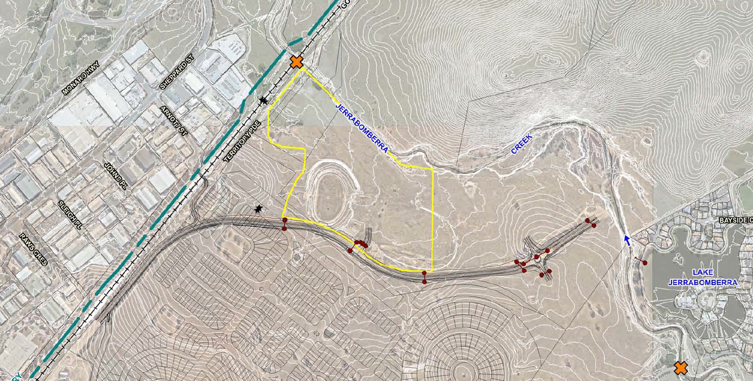
Natural Water Course – 360A Lanyon Drive, Tralee

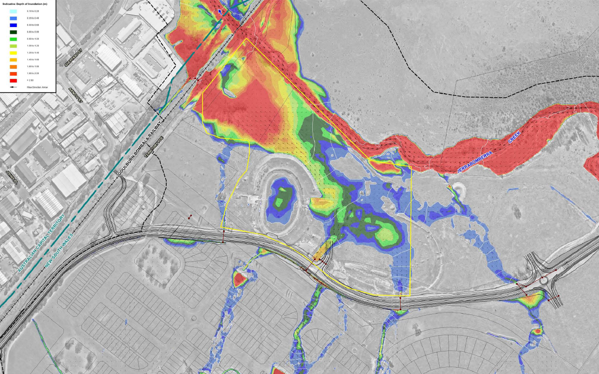
1% AEP Flood Area and Depth of Inundation (pre-development) – 360A Lanyon Drive, Tralee

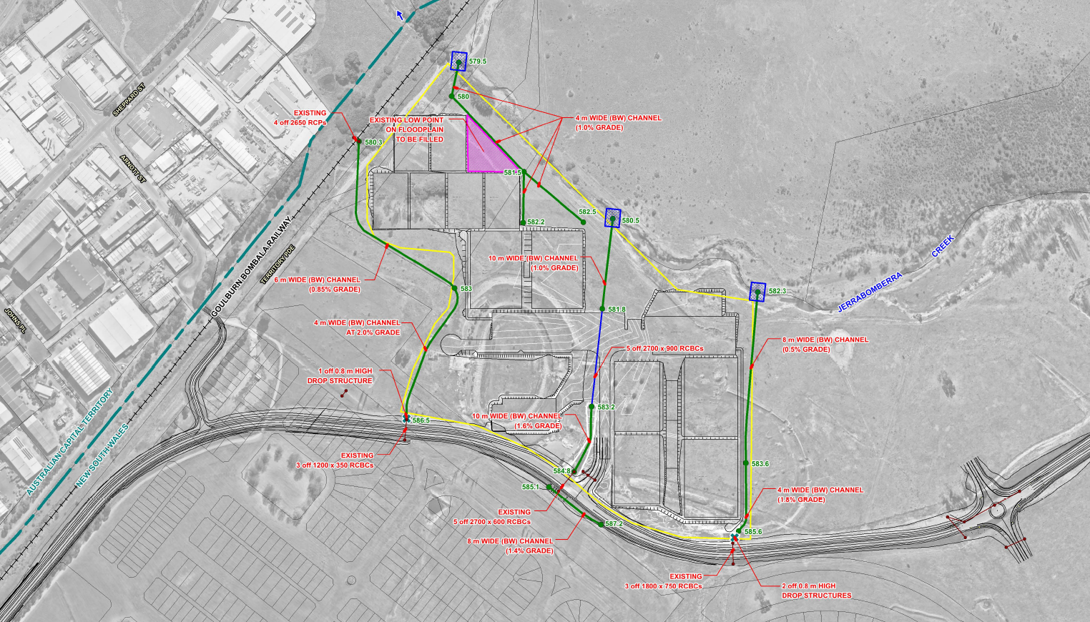
Stormwater Drainage Strategy – 360A Lanyon Drive, Tralee

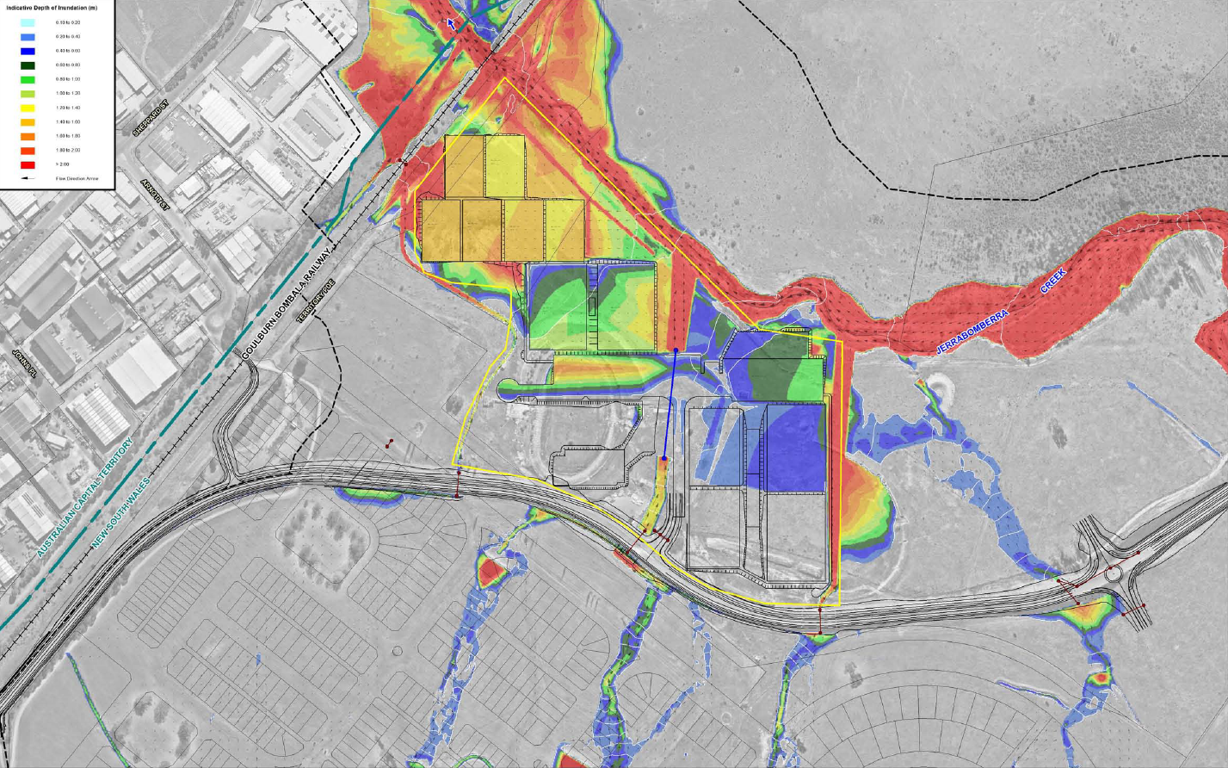
1% AEP Flood Area and Depth of Inundation (post-development) – 360A Lanyon Drive, Tralee

SECTION 64 CONTRIBUTIONS
The basketball stadium building has proposed 22 WCs and 15 showers, the major pavilion building has proposed 22 WCs and 15 showers and the two minor pavilion buildings have a combined proposed 42 WCs and 28 showers. In the major pavilion there is a proposed function room with kitchen and bar with a floor area of 150m². In the basketball stadium there is a proposed café with kitchen and bar with a floor area of 160m².
The following Section 64 contributions were calculated with reference to the NSW Water Directorate Determinations of Equivalent Tenements – April 2017 for Café/WC/shower amenities on pages 32 and 33.
- WCs = 86 (Water ET = 0.4/WC and Sewer ET = 0.63/WC)
- Showers = 58 (Water ET = 0.4/Sh and Sewer ET = 0.63/Sh)
- Cafés = 310m² (Water ET = 0.1/m² and Sewer ET = 0.1/m²)
Subsequently, the water and sewer headworks contributions for South Jerrabomberra/Tralee are calculated at 60.70 ET and 93.82 ET respectfully for the following amounts for current Section 64 plans;
- Jerrabomberra Water Headworks for 60.70 ET = ($9,333.51 x 60.70).
- Queanbeyan West Zone Sewer Headworks for 93.82 ET = ($1,496.96 x 93.82).
However, the site will generate a credit from the subdivision of the land parcel creating the 23 Ha QPRSC lot of 15 ET per gross hectare, which applies in this instance.
- Credit_{(W&S)} = 15 x 23Ha = 345ET
Subsequently, Section 64 contributions do not apply to this public facility and community development.

DEVELOPMENT CONTRIBUTIONS SEC.7.11
Section 7.11 contributions do not apply to this public facility and community development.

Health and Environment

Health and environment matters assessed:
☒Food | ☐Air pollution and odour
☐Skin penetration & beauty | ☐Water pollution
☐Other public health | ☐Hazardous industry (SEPP 33)
☒Nosie | ☒Contaminated land (SEPP 55)
☒Sediment and erosion control | ☐Other

Recommended Environmental Health Conditions

Environmental Health supports the development application, subject the following conditions:

Standard conditions: | DA.10.115
Standard conditions (edited): | DA.02.03, DA.08.07, DA.08.08
Other recommendations:

Comments

Council’s Heritage Adviser

Place | 360A Lanyon Drive Tralee
Issue | DA.2020.1351 Regional Sports Complex  Shelter structure
Contact | Jacinta Tonner

The former Tralee amenities building had fallen into ruined condition in the decades since its active phase.

However it retained some interesting characteristics in the surviving walls that included early use of Canberra red brick that was faced on the outside with a particularly attractive field stone. The walls included distinctive arched openings, and on the corners the brick and stone laminated wall had been angled outwards to form a buttress that added both visual and structural strength to the relatively small building.

The building’s structural failure was probably due to multiple factors including its weight relative the bearing capacity of the ground, and overall the structure was assessed as beyond feasible salvage.

The conservation strategy has been to utilise the salvaged stone and some of the key design elements of the former amenities building to create a new structure that will continue to serve the next generation of sporting fans. This can be seen in the internal redbrick facing, the salvaged stone on the exterior of the wall, the inclusion of arched openings and the use of angled buttresses at the corners.

The proposed shelter is a very good example of the way in which key attributes of a redundant and problematic heritage structure can be reinterpreted in a modern and sympathetic way.

Council’s Building Surveyor

I have completed my assessment and raise no objection to the proposal. The proposal appears likely to comply with the BCA and given the cost of works, Council will not be able to act in a certifying capacity for this development

